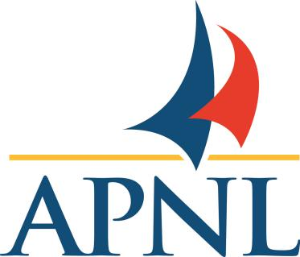
2021 FULL MEMBER RENEWAL FORM
April 1, 2021 - March 31, 2022

Title:_____ Surname: __________________ Given Name: _______________

Preferred Contact Info:
Address:__________________________________________________________________
City/Town:___________________________________ Postal Code:__________________
Phone: (P)___________________ (C)____________________ (O)___________________
Email(required): _______________________________________Fax: _________________

Geographical area of work:
St. John’s/Metro Avalon Peninsula/East Central
West Labrador Other _____________________

Please indicate any activities in which you are interested in participating.
- APNL Committees/Reps
Executive Continuing Education Advocacy
Membership Psych Month Activities Newsletter

- Peer Counselling/Consult
I am willing to provide peer counseling or consultation to fellow APNL members on a pro bono basis (Not intended as a means of psychological counselling or intervention)

- Public Speaking
I am available to offer presentations or respond to requests to speak to:
Fellow Psychologists Media Public/ Community
on the following psychology related topic(s)/issue(s):
____________________________________________________________________
____________________________________________________________________

For APNL Office Use Only
Date: ___________________ APNL#: ________________ Member Category: ______________
Fees Paid: ______________ Receipt#: ______________

Renewing Members must meet ONE of the following criteria:

- I am a Full or Provisional Registrant with the Newfoundland Labrador Psychology Board (or an
equivalent Provincial/State Licensing Board) ____________ Board and Registration Number

OR

- I hold a graduate degree (Master’s or Doctorate) in Psychology acceptable to APNL

Please CLEARLY indicate your Renewal FULL Membership Category and applicable fee below

DEADLINE: March 31,2020 (Late Renewal Fee additional $25.00 if renewing after March 31, 2021).

Before March 31st, 2021
$200 Full Member
$190 Full Member with CPA membership (CPA Member # )

After March 31, 2021
$225 Full Member
$215 Full Member with CPA membership (CPA Member # )

Signature: ___________________________________ Date:_________________________

Payment Options - NOTE: All Payments will be processed after April 1
Cheque/Money Order to - APNL P. O. Box 26061, RPO LeMarchant Road, St. John's, NL A1E 0A5

E -Transfer - All e-transfers must use the following:
Email : membership@apnl.ca
Security Question - What for
Security Response - Membership2021

